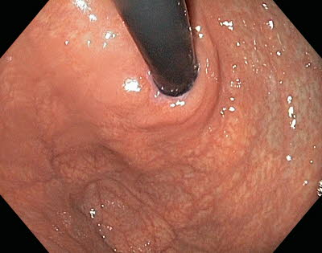

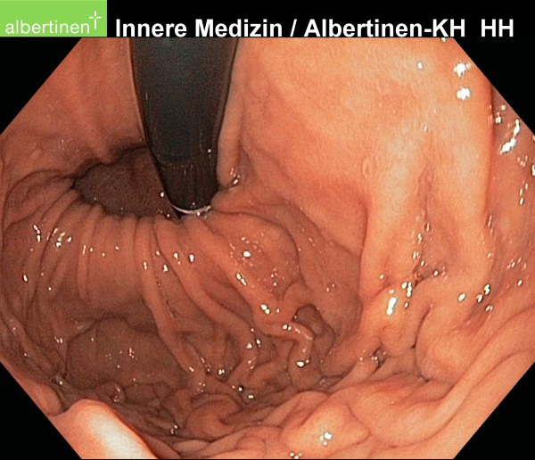
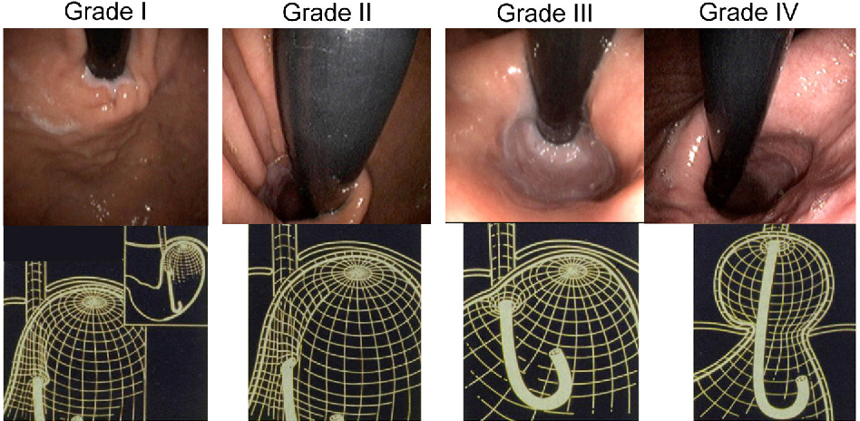
Endoscopic appearance and corresponding three-dimensional representation of the progressive anatomic disruption of the gastroesophageal junction as occurs with development of a Type I hiatus hernia. In the grade I configuration, a ridge of muscular tissue is closely approximated to the shaft of the retroflexed endoscope. With a grade II configuration the ridge of tissue is slightly less well defined and there has been slight oral displacement of the squamocolumnar junction along with widening of the angle of His. In the grade III appearance the ridge of tissue at the gastric entryway is barely present and there is often incomplete luminal closure around the endoscope. Note, however, that this is not a hiatal hernia because the SCJ is not displaced axially in the endoscopic photograph. With grade IV deformity, no muscular ridge is present at the gastric entry. The gastroesophageal area stays open all the time, and squamous epithelium of the distal esophagus can be seen from the retroflexed endoscopic view. A hiatus hernia is always present with grade IV deformity.

